Environmental Justice Outline
Name
Institution Affiliations
Course Title
Date

INTRODUCTION:
- Definition of Environmental justice
- The goal of environmental justice
- The history of environmental justice
- How environmental justice relates to interdisciplinary social science literature, environmental policies, and laws
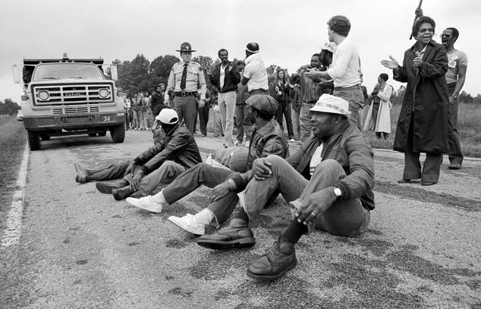
The photo shows Protestants blocking the delivery of toxic PCB waste to a landfill in Afton, North Carolin in the year 1982
PRINCIPLES OF ENVIRONMENTAL JUSTICE:
- The public approach to environmental justice
- The key right to political, financial, social, and environmental self-assurance, all things considered.
- The option to take an interest as equivalent accomplices at each degree of dynamic
- The privilege of the individuals who work at home to be liberated from environmental perils.
- Administrative demonstrations of natural bad form an infringement of global law,
- A unique legitimate and normal relationship of Local People groups
- The severe authorization of standards of educated assent, and an end to the testing of exploratory regenerative and operations and inoculations on minorities.
- Environmental justice goes against the dangerous tasks of worldwide companies.
- Environmental justice goes against military occupation, restraint and abuse of grounds, people groups and societies, and other living things.
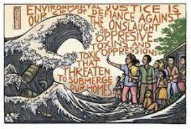
Environmental justice and eco-social justice: This photo was drawn to tell Canada’s leaders to redress environmental racism.
BARRIERS TO ENVIRONMENTAL JUSTICE
- Initial barriers to the participation of minorities
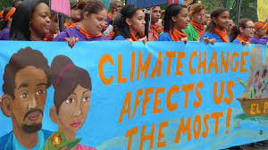
The intersection of social justice and environmentalism. This photo advocate for inclusivity in environmental justice since it affects all of us.
- Cost barriers

This photo shows costs as a barrier to environmental justice
- The issue of a fair process
OVERCOMING BARRIERS TO ENVIRONMENTAL JUSTICE
- Communities need to understand the benefits of green infrastructure.
- There is a need to develop pilot programs that will equip the community with knowledge and experience for developing and implementing environmental justice approaches.
- Recognize the multiple benefits of environmental justice
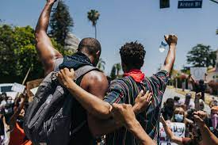
Racial justice and involvement of everyone in environmental justice

WAYS TO SUPPORT ENVIRONMENTAL JUSTICE EVERY DAY
- Practice Self-Education
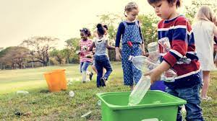
Children being taught environmental on environmental conservation in efforts to establish a generation that minds about environmental health and conservation.
- Raise the Voices of the Affected People group
- Consider Your Delegates Responsible
- Utilize the Force of Boycott
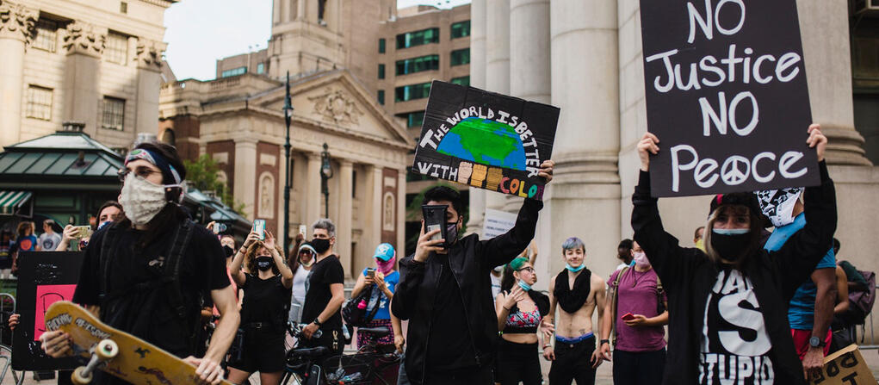
Advocates and allies in this fight for environmental justice
CONCLUSION
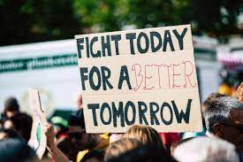
If we fight for environmental justice today, we will have a better environment to work, learn and live in tomorrow.
BIBLIOGRAPHY
REFERENCE

